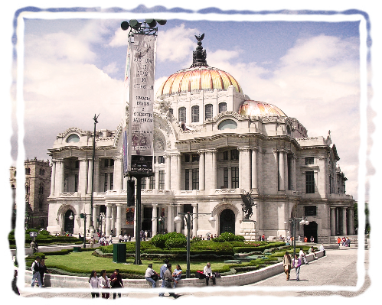
Registration Form
Small-Group Mexico City Tour
November 6, 2022, to November 13, 2022
Registration Deadline September 20th
\

Register Today
$1495.00 per person, based on double occupancy.
Single occupancy supplement $175.00
Deposit $250.00
Tour Minimum 8 ~ Maximum 12
Registration Deadline: September 20, 2022
The final payment is due: October 3, 2022
For Questions, Please Contact
Dan Chavez, Email: fotoventures@gmail.com or tel: 520-904-5730

Name as shown
on passport: _________________________________________________
Email: _________________________________________________
Address: _________________________________________________
_________________________________________________
Mobile Ph: ___________________ Home Ph: __________________
My roommate will be: __________________________________________
Please assign me a roommate (for solo travelers only)
Single room ($175 single supplement applies).
Preference: twin full/queen

Proof of full COVID vaccination and boosters are attached.
age 60 or older teacher/faculty student
(Mexico City museums have special pricing based on the above)
)

$250 Deposit Payment
Your deposit may be made electronically through your bank via Zelle to fotoventures@gmail.com or via the Venmo app to @Daniel-Chavez-175. Should you wish to pay using a credit card, let us know, and we will invoice you via PayPal.

The final payment will be due no later than October 3, 2022.

[Please print and complete form, then email PDF copy to fotoventures@gmail.com]

